Table S1:
Euclidean distance between the input features and predicted features in BVN inference
 | Male | Female
#0 | 2.482541457 | 3.331276657
#1 | 2.720487598 | 2.694632179
#2 | 1.66202945 | 3.809493684
#3 | 3.657397365 | 2.139857406
#4 | 2.389329198 | 4.170589669
#5 | 2.303908441 | 2.019533422
#6 | 3.347863027 | 2.11368229
#7 | 2.182303472 | 1.71244637
#8 | 3.843715168 | 1.880469296
#9 | 1.734531436 | 3.15907759
#10 | 2.808226378 | 3.956929232
#11 | 2.230135848 | 1.253912229
#12 | 2.964873046 | 1.488445363
#13 | 2.817682937 | 2.241708491
#14 | 1.558078357 | 3.944965023
#15 | 1.841580056 | 4.077664846
#16 | 4.204951677 | 1.491057924
#17 | 2.671106759 | 2.851783579
#18 | 2.623997328 | 1.777050773
#19 | 2.779465487 | 2.613932464
#20 | 1.776870163 | 2.670845646
#21 | 0.626026685 | 1.616925062
#22 | 3.212388352 | 2.900317761
#23 | 5.108908067 | 1.562128443
#24 | 4.065310692 | 0.855507847
#25 | 2.742951337 | 1.942464405

Figure S1
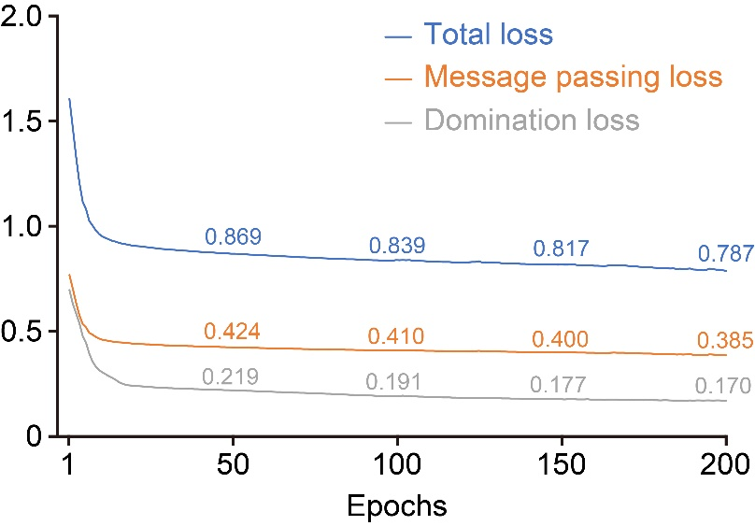
Training loss progression during BVN model training. Changes in total loss, message passing loss, and domination loss over 200 epochs are shown. Total loss was calculated as 2.0 × message passing loss + 0.1 × domination loss. Detailed methods for the loss functions, training targets, and loss calculation procedures have been described in our previous study (Ref. 12).

